**USE AQUAPONICS**

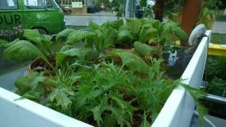 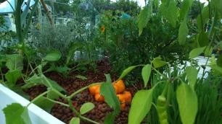

The aquaponics crops looked delicious

I knew very little about aquaponics, so it was interesting to talk to Emerald from Aquaponic Life, a Community Interest Nonprofit Company, who had set up this section of the garden. She told me that aquaponics are a viable option for small gardens or even indoor fishtanks. The closed-loop system involves using the nitrogenous waste excreted by the fish to provide nutrients for the plants which are grown hydroponically (in water without using soil). The plants, in turn, filter the water, which is returned clean for the fish. This continuous cycle uses 90-98% less water than conventional methods. Aquaponic Life run courses in their home town of Brighton to train people about how these systems can be used in homes and gardens. The company is currently crowdfunding to develop their home aquaponics system so that more people can use this sustainable method of food production. They also hope to develop their work in school and universities, and create an urban farm in or near the centre of Brighton as a teaching resource to help put food security back into the hands of families and communities. I will be watching and supporting their progress with interest and if we acquiesce on the pet front with the children next year, maybe Tilapia will be our pet of choice.